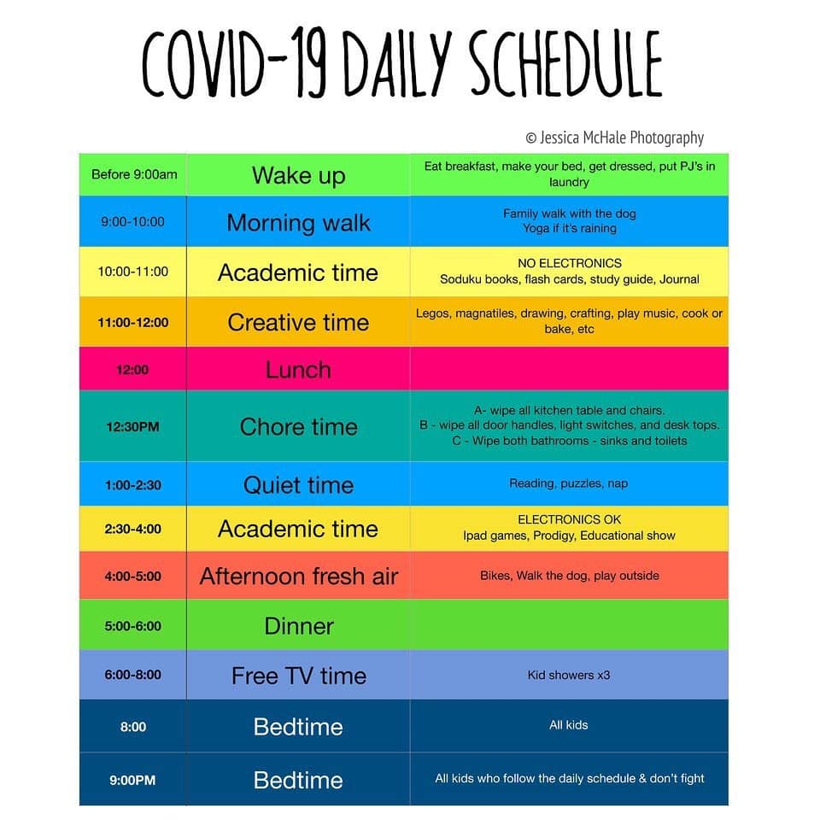

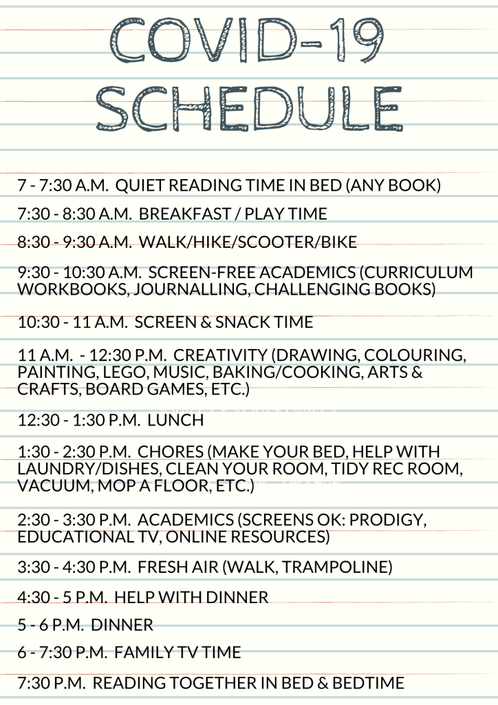
Welcome, this site uses cookies. Read our privacy policyClose
Close

Tes for schools Log in Register for free
ResourcesJobsNewsMagazineCommunityCoursesLog outHelp
Home feed
My list
Courses My Jobs Job alerts My CV Career preferences Resources Author dashboard
Settings
Edit accountLog out
HomeResourcesJobsNewsMagazineCommunityCoursesRegister for freeLog inHelp

Register for free
Already registered?
Log in

Jobs
My jobsJob alertsMy CVCareer preferences

Resources
DownloadsSaved resourcesAuthor dashboardAdd resourceMy shopTes Elements

Community

Courses
Access courses

News
MagazineSubscriptionsPaymentsAbout usMy productsTes for schoolsWork for Tes
Free
Download
Save for later

Coronavirus (Covid-19) Lesson

Author: Created by
JohnT123
Preview
Created: Feb 14, 2020

I have made a 60 minute lesson on the ‘geography in the news’ topic of Covid 19. KS3/ KS4 Geography resource complete with booklet that the students can work through.
The impacts are up to date as of the 10th of Feb.
Used with Year 9 and Year 8 and both thoroughly enjoyed exploring the misconceptions and impacts. A perfect follow up would be further justification or responses to the virus, comparing it to SARS or EBOLA.
Stretch and challenge are provided throughout as well as handy word boxes and some sentence starters.
I would brush up on the recent news on the virus before teaching as students have lots of questions around the topic, but so far it has been effective and engaging.
Enjoy :)
Read more
Free
Download
Save for later
Preview and detailsFiles included (2)

- 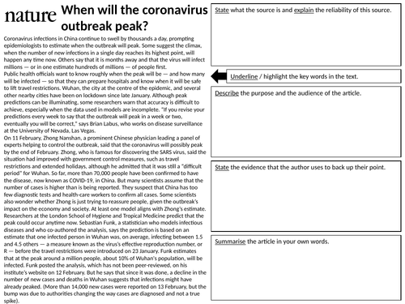
Resource author:JohnT123
NextPrevious
Download
3 Files, 20 MB
Welcome, this site uses cookies. Read our privacy policyClose
Close

Tes for schools Log in Register for free
ResourcesJobsNewsMagazineCommunityCoursesLog outHelp
Home feed
My list
Courses My Jobs Job alerts My CV Career preferences Resources Author dashboard
Settings
Edit accountLog out
HomeResourcesJobsNewsMagazineCommunityCoursesRegister for freeLog inHelp

Register for free
Already registered?
Log in

Jobs
My jobsJob alertsMy CVCareer preferences

Resources
DownloadsSaved resourcesAuthor dashboardAdd resourceMy shopTes Elements

Community

Courses
Access courses

News
MagazineSubscriptionsPaymentsAbout usMy productsTes for schoolsWork for Tes
Free
Download
Save for later

Coronavirus (Covid-19) Lesson

Author: Created by
JohnT123
Preview
Created: Feb 14, 2020

I have made a 60 minute lesson on the ‘geography in the news’ topic of Covid 19. KS3/ KS4 Geography resource complete with booklet that the students can work through.
The impacts are up to date as of the 10th of Feb.
Used with Year 9 and Year 8 and both thoroughly enjoyed exploring the misconceptions and impacts. A perfect follow up would be further justification or responses to the virus, comparing it to SARS or EBOLA.
Stretch and challenge are provided throughout as well as handy word boxes and some sentence starters.
I would brush up on the recent news on the virus before teaching as students have lots of questions around the topic, but so far it has been effective and engaging.
Enjoy :)
Read more
Free
Download
Save for later
Preview and detailsFiles included (2)
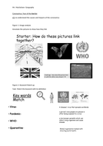
pptx, 20 MB
Corona-virus-lesson-final
docx, 621 KB
Coronavirus-Booklet

About this resource

Info
Created: Feb 14, 2020
pptx, 20 MB
Corona-virus-lesson-final
docx, 621 KB
Coronavirus-Booklet
Report a problem

7 Reviews
5

behiye79a day agoreport

vickigo788 days agoreport
Really visual and useful resource. Thanks

MariaBarberis14 days agoreport
Great resource. I love working with images and this is a great PPT. It only has to be updated but is easy to do so on this PPT Template

claudia_grafa month agoreport

pnmasonuka month agoreport
A very useful current resource.
View more reviews

Categories & Ages
Geography
Geography / Development and urbanisation
Geography / People and environment
Whole school
11-14
14-16

Creative Commons "Sharealike"

Recommended resources
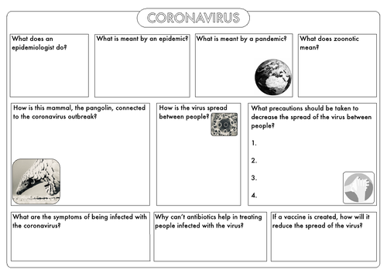
beckystoke

Coronavirus Worksheet
Free

Mrs_B

Coronavirus outbreak facts, slides and questions
Free

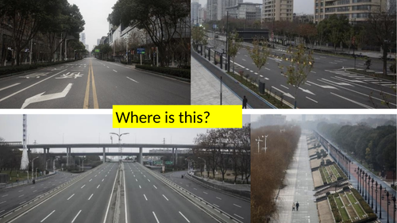
ruthgillott

coronavirus GCSE lesson
Free

Paul Foster

Coronavirus In The News
Free

community forum
Senior Leadership Team
Members of senior management teams can share career tips, get advice on staff management and generally get a helping hand from your peers.

Recommended News

Climate change: Teaching the truth of natural disasters.
Schools must prepare young people...

Geography 'suits posh pupils struggling with three Rs'.
Geography considered 'soft subject'...

Cover lessons: a chance to complete your own education.
A well-planned cover lesson offers a...

The teachers risking their jobs to save the planet.
Three teachers defaced the DfE...

Dear madam: letters to the editor 14/10/19.
In this week's postbag of letters to the editor,...

featured course

Better Voice for Teachers part one and two CPD
Better Voice for Teachers is a dynamic, easy-to-follow online course designed to help you hold your pupils'... More
6-8 hours View Course
Jobs Jobs homeUKInternationalAustraliaPrimary / ElementarySecondary / High schoolCareers adviceTes for schools
Courses Courses homeFor prospective teachersFor teachersFor schoolsFor partners
Resources Resources homeEarly years / Pre-K and Kindergarten Primary / Elementary Middle schoolSecondary / High school Whole schoolSpecial Educational NeedsBlog
Store Store homeElementsMagazineCommunity Community homeLatest postsSearch forumsEducation newsTeaching overseasUS education news
News News homeNewsFE newsMagazineNew teachersPartners

Copyright © 2020
Chat About us FAQs Contact us Privacy Terms & conditions Fair recruitment policy Takedown Work for Tes Modern slavery statement
This website and its content is subject to our Terms and Conditions. Tes Global Ltd is registered in England (Company No 02017289) with its registered office at 26 Red Lion Square London WC1R 4HQ.
Close

Resource author:JohnT123
NextPrevious
Download
3 Files, 20 MB

Cover Image
pptx, 20 MB
Corona-virus-lesson-final
docx, 621 KB
Coronavirus-Booklet

